Table of Contents

1. INTRODUCTION
Imagine that you are in a room where ‘m’ people are speaking simultaneously. You have ‘n’ microphones, which you hold in different locations. The microphones act as an input source for the sound signals, which we could denote by x₁(t), x₂(t)…. X_{n}(t), with x_{i} ,1≤i≤n. the amplitudes, and t time index. Each of these recorded signals is a weighted sum of the speech signals emitted by the speakers, which we denote by s_{j}(t) 1≤j≤m. We could express this as a linear equation:
x₁(t) = a₁₁s₁+a₁₂s_{2….} a_{1m}s_{m} (1)
x₂(t) = a₂₁s₁+a₂₂s₂ ….. a_{2m}s_{m} (2)
where a_{ij} (1≤i≤n ) and (1≤j≤m ) are parameters that depend on the distances of the microphones from the speakers. It would be very useful if you could now estimate the original speech signals s_{j}(t) using only the recorded signals x_{i}(t) .
This is called the cocktail-party problem
As an illustration, consider the waveforms in Fig. 1 and Fig. 2.
The original speech signals could look something like those in Fig. 1 and the mixed signals could look like those in Fig. 2. The problem is to recover the data in Fig. 1 using only the data in Fig. 2.
One approach to solving this problem would be to use some information on the statistical properties of the signals s_{i}(t) to estimate the a_{ii}. We can safely assume that s_{j}(t), at each time instant t, are statistically independent. Independent Component Analysis, or ICA, can be used to estimate the parameters a_{ij} on the information of their independence, which allows us to separate the original source signals s_{j}(t) from their mixtures x_{i}(t). Fig. 3 gives the two signals estimated by the ICA method. As can be seen, these are very close to the original source signals
Fig1: Original Signals:

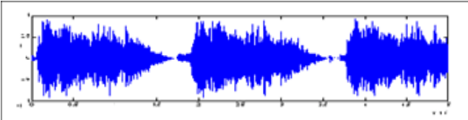
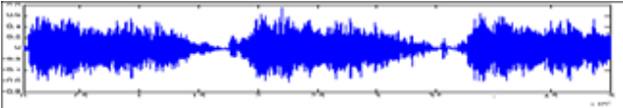

Fig 2: Observed Signal:
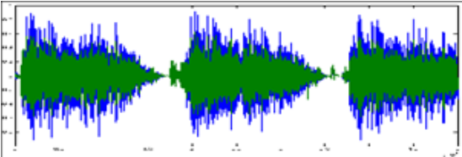

Fig 3:Output Signal Computed from the Algorithm:
Signal 1 Signal 2
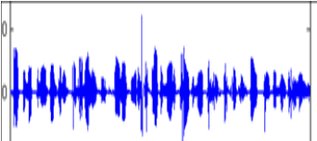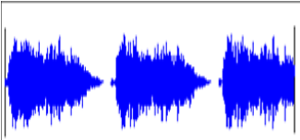

2. INDEPENDENT COMPONENT ANALYSIS
Independent Component Analysis (ICA) is a method of decomposing a multi-dimensional data set into a set of statistically independent variables.
The method relies upon the fact that mixtures of independent variables tend to become more Gaussian in distribution when they are mixed linearly (by the Central Limit Theorem).[2] The model is identifiable under the following fundamental restrictions: at most one of the independent components sj may be Gaussian, and the matrix A must be of full column rank. [15]
In order to recover the independent sources we should maximize some measure of non-Gaussianity.[6]
ICA defines a model for the observed multivariate data. In the model, the data variables are assumed to be linear mixtures of some unknown latent variables, and the mixing system is also unknown. The latent variables are assumed non-Gaussian and mutually independent and they are called the independent components of the observed data. These independent components, also called sources, can be found by ICA[1].
Let us assume that we have an observed signal x. It is a multidimensional variable, and can be described as
x = [x₁;x₂;x₃;x₄……x_{n} ] (3)
The observed signal is itself a collection of the source signals s, such that s_{i} is independent of the other source signals s_{k} (1<=k<=m, k!=i), meaning there is no impact on the other signals if one of them experiences any changes.
The actual signals are assumed to be mixed by a matrix, thus creating the observed signal, x.
Therefore,
x₁= a₁₁ *s₁+ a₁₂ * s₂ ....a_{1n}*s_{n}
x₂= a₂₁ * s₁ + a₂₂.s₂ .... a_{2n}*s_{n}
.
.
x_{n}= a_{n1}*s₁+a_{n2}*s₂ ......a_{nn} * s_{n}
We can hence write the signal x as a vector which has been created by the effect of the disturbance (mixing matrix) A on original source signals s.
x = As (4)
A is the matrix which is used to modify the signals, hence also known as disturbance. The mixed signals may also experience additional noise α. The net equation thus becomes:
x = As + α (5)
The main aim of ICA is to correctly estimate the original source signals s, given the observed vector x, which constitutes of the original signal modified by an unknown event (a matrix) A and a noise α [7,15]
The determination of the original signal without prior knowledge of the original signal or the mixing matrix is the idea behind ICA.
To determine the estimating matrix, and therefore the original signals, the input i.e. the mixed data ‘x’ is prewhitened. Prewhitening converts the input data 'x' into an observed vector 'v' where the elements v_{i} are mutually exclusive, and have unit variance. Data scaled to unit variance is the operation of centering the observed vectors such that each feature (in each column of your data matrix) has a variance (or equivalently, its standard deviation) with value 1.0. Scaling to unit variance is usually performed after centering the data (removing the feature-wise mean).Prewhitening also helps reduce the noise. Therefore, for a Prewhitening Matrix 'M', and observed signal 'x', the whitened vector 'v' is observed as [10]:
v=Mx=MAs (6)
Our Aim in ICA is to find the independent components from the pre-whitened matrix ‘v’. To do the same, we use
s=Wv (7)
where W*M is the pseudo-inverse estimate of the matrix A.

2.1 Assumptions in ICA
- The starting point for ICA is the very simple assumption that the components s_{i} are statistically independent. We must also assume that the independent component must have non-Gaussian distributions. [1], or at most one signals can be gaussian[15]
- For simplicity, we are also assuming that the unknown mixing matrix is square, but this assumption can be sometimes relaxed.
- A basic assumption in ICA is that the elements of Original Source Signals(S),denoted by s_{ij}, are mutually independent signals with probability density functions (pdf’s) being defined as[9]
p_{i} (s_{i})_{j}; i,j=1….d (8)
A probability density function (pdf) of a Continuous random variable is a function that describes the relative likelihood for this random variable to take on a given value. The probability for the random variable to fall within a particular region is given by the integral of this variable’s density over the region. The probability density function is nonnegative everywhere, and its integral over the entire space is equal to one.
- Another key assumption in ICA is that unknown matrix is a full column rank. Maximum Rank corresponds to the Linearly Independent set .Column Rank therefore would be the maximum number of Linearly Independent Columns.[9]
- In the simplest form of ICA, we must assume that 'm' variables are the linear combination of 'n' unknown independent components , such that the variables are statistically independent and zero-mean, with n<=m. When zero-mean normalization is applied, all the data in each profile are slid vertically so that their average is zero
- The basic problem of ICA is to estimate the original components from the mixtures correctly in terms of sign and magnitude. This problem arises because any constant multiplying an independent component in (5) could be canceled by dividing the corresponding column of mixing matrix A by the same value.
- We assume that the signals are at unit variance (E{y²}=1)[1,6,7,10].This makes the Non Gaussian components unique.

2.2 Features of ICA
Two interesting applications for ICA are perhaps, for performing blind source separation, or for feature extraction [2, 10]. Independent Component Analysis is used to determine from an observed input, the set of non Gaussian, statistically independent source signals.
Components involved in ICA must be non-Gaussian, as it is the basis for identifiability of the model in (5) [13]. To determine this condition we can use 2 methods effectively:
a. Kurtosis:
Kurtosis of any variable y classically defined by:
A frequently encountered statistics in ICA is kurtosis, or fourth-order cumulant.
Kurtosis(y) = E { y⁴} − ( E{y²} )²
One of the assumptions of ICA is that we keep the signals at unit variance (E{y²}=1)[1,6,7]. Therefore the net equation is:
Kurtosis(y) = E { y⁴}
If our signals have kurtosis equal to zero, they are Gaussian in nature, and cannot be computed by ICA. Therefore the definition of kurtosis is intuitive since it vanishes if y is Gaussian.
However, kurtosis has also some drawbacks in practice, when its value has to be estimated from a measured sample. The main problem is that kurtosis can be very sensitive to outliers, as observed by Huber [3]. Its value may depend on only a few observations in the tails of the distribution, which may be erroneous or irrelevant observations. In other words, kurtosis is not a robust measure of non-Gaussianity. [1] However, kurtosis has also some drawbacks in practice, when its value has to be estimated from a measured sample.
For a Gaussian random variable, Kurtosis is zero. For densities peaked at zero, it is positive, while it is negative for flatter densities. If two random variables v₁ and v₂ are independent, then kurtosis (v₁ + v₂) ₌ kurtosis (v₁) + kurtosis (v₂)

b. Negentropy:
A general formulation of ICA, which does not need the underlying model (5), has its definition based on mutual information. Differential Entropy H(y) , for a random vector y=(y₁….y_{n})^{T} with p.d.f. f(.) is defined as
H(y) = -∫ f(y) log f(y) dy (9)
Differential Entropy gives rise to the definition of Negentropy. Negentropy is based on the information of (differential) entropy. The more “random”, i.e. unpredictable and unstructured the variable is, the larger its entropy. Negentropy can be considered as a measure of non-gaussianity. A Gaussian variable has the largest entropy among all random variables of equal variance [4]
To obtain a measure of non-Gaussianity that is zero for a Gaussian variable and always nonnegative, one often uses a slightly modified version of the definition of differential entropy, called negentropy. Negentropy J defined as follows[1]
J(y) = H(y_{gauss})−H(y) (10)
Mutual Information I, used to measure the correlation between the random variables can be found by:
I (y_{1,} y₂….y_{n})=J(y) -∑_{i} J(y_{i}) (11)
ICA uses the property, and tries to minimize the mutual information of the transformed components s_{i} in (7).Since entropy is highest for a Gaussian distribution, negentropy is always non-negative, and it is zero if and only if y has Gaussian distribution.[4,5,12]
Minimizing Mutual Information is equivalent to finding the direction for a vector with random variables in which the Negentropy is maximized. Based on Maximum Entropy Principle, the above definition for Negentropy, to be used for FastICA is modified to the below model.
J_{G}(w)=[E{G(w^{T}x)}- E{G(ﬠ}]² (12)
In the above definition, G is any non-quadratic function [13], ﬠ is a Gaussian variable of zero-mean and unit variance. w is an m-dimensional weight vector.
Using the above model, ICA aims to solve an optimization problem: Maximize the function J_{G} under the constraint E{w^{T}x}²=1

2.3 Distribution of ICA Algorithms
The ICA algorithms can be divided in 2 ways:
The first division is based on the types of Algorithms:
- The first category algorithms rely on batch computation, minimizing or maximizing some relevant criterion. The problem with these algorithms is that they require complex matrix operations.
- The Second Category contains adaptive algorithms, often based on gradient methods. These algorithms have slow convergence. and convergence depends on the correct choice of learning parameters, when implemented on Neural Networks.
The second division is based on the method of Approach, namely “top-down" and “bottom-up" approaches to ICA:
- In the top-down approach, independence is measured by such measures as mutual information which is often approximated by using cumulants. This may result in non-robust contrast functions and burdensome computations.
- In the bottom-up approach, the higher-order statistics are implicitly embedded into the algorithm by arbitrary non-linearity. The bottom-up approach is computationally simple, and the non-linearity can be chosen quite freely to optimize e.g., the statistical behavior of the estimator.[9]

3. FASTICA

3.1 Introduction
FastICA is a computationally efficient algorithm for Independent component analysis. The algorithm is based on a fixed-point iteration scheme maximizing Non-Gaussianity as a measure of Statistical independence. [1, 6]
Advantages of FastICA
- It has been found that FastICA can be 10-100 times faster than conventional methods for ICA.
- It can be used to perform projection pursuit as well, thus providing a general-purpose data analysis method that can be used both in an exploratory fashion and for estimation of independent components (or sources).[9]
- Though gradient based algorithm, there is no learning rate or adjustable parameter, which makes the algorithm more reliable.
The FastICA algorithm is designed to provide a computationally quick method of estimating the unobserved independent components. The algorithm iteratively maximizes an approximation to the negentropy of the projected data. Since Gaussian variables have the largest entropy among all random variables of equal variance, entropy can be used to define a measure of non-Gaussianity i.e. negentropy. [6]
The FastICA is based on a fixed-point iteration scheme for finding a maximum of the non-Gaussianity of w^{T}x.
FastICA is known to be sensitive to its initialization (the weighting matrix is randomly initialized, or specified by the user. When a non-convergence is met, it simply starts off with a re-initialization of the weighting vector for that component. This can easily be explained by the use of Newton-like gradient algorithms that are optimal for local minima, though not for global optimization.
The basic form of the FastICA algorithm is as follows:
1. Choose an initial (e.g. random) weight vector w.
2. Let w+= E{xg(w^{T}x)}－E{g’(w^{T}x)}w
3. Let w = w+/||w+ ||
4. If not converged, go back to 2.
Note that convergence means that the old and new values of w point in the same direction, i.e. their dot-product are (almost) equal to 1. It is not necessary that the vector converges to a single point.[9]

3.2 Properties of the FastICA Algorithm
The FastICA algorithm has a number of desirable properties when compared with existing methods for ICA.
1. The convergence is cubic (or at least quadratic), under the assumption of the ICA data model [3]. This is in contrast to ordinary ICA algorithms based on gradient descent methods, where the convergence is only linear. This means a very fast convergence, as has been confirmed by simulations and experiments on real data.
2. The algorithm finds directly independent components of (practically) any non-Gaussian distribution using any non linearity g. This is in contrast to many algorithms, where some estimate of the probability distribution function has to be first available, and the nonlinearity must be chosen accordingly.[1,7]
3 The performance of the method can be optimized by choosing a suitable nonlinearity g. In particular, one can obtain algorithms that are robust and/or of minimum variance.
4. The independent components can be estimated one by one, which is roughly equivalent to doing projection pursuit.[6]
5. The FastICA has most of the advantages of neural algorithms: It is parallel, distributed, computationally simple, and requires little memory space.[8]

3.3 Cost Function for FastICA

Cost function to be used for FastICA need to have the following properties:
- Consistency : An estimator is assumed to be consistent and globally stable if it can estimate the independent components s_{i} satisfies the below equation, for a square mixing matrix A, and under the constraint that E{w^{T}x}²=1:
[E {s_{i}g(s_{i})}- g’ (s_{i})] [E{G(s_{i})}- E{G(ﬠ}] (13)
In the above definition, G is any non-quadratic function [13], ﬠ is a Gaussian variable of zero-mean and unit variance. w is an m-dimensional weight vector.
- Robustness: FastICA cost function is also needed to be robust to outliers. As explained later, outliers can affect the data observation, and can modify the mean of the data samples. The cost function should be bounded to the maximum extent, if not completely, and not grow very fast.
- Computational Simplicity: The Contrast function should be fast and easy to compute and not take too much time as it would spoil the quickness of the Algorithm itself.

3.4 Maximum Likelihood Estimation in FastICA
3.4.1 The likelihood
A very popular approach for estimating the ICA model is maximum likelihood estimation. Here we discuss this approach, and show that it is essentially equivalent to minimization of mutual information. It is possible to formulate directly the likelihood in the noise-free ICA model, and then estimate the model by a maximum likelihood method. Denoting the matrix A⁻¹ by W= (w₁, ...,w_{n})^{T}, the log-likelihood takes the form
L =^{T}∑_{t=1} ^{n}∑_{i=1} log f_{i} (w^{T}_{i}x(t))+T log|detW| (14)
where f_{i} are the density functions of the original signals s_{i} (here assumed to be known), and the x(t), t = 1, ...,T are the realizations of x. The term log|detW| in the likelihood comes from the classic rule for (linearly) transforming random variables and their densities. Another approach for ICA estimation, inspired by information theory, is minimization of mutual information. We will explain this approach here, and show that it leads to the same principle of finding most nongaussian direction as was described above.

3.4.2 Mutual Information
Using the concept of differential entropy, we define the mutual information I between m (scalar) random variables, yi, i = 1...m as follows
I(y₁,y₂, ...,y_{m}) = ^{m}∑_{i=1} H(y_{i})−H(y). (15)
Mutual information is a natural measure of the dependence between random variables. It is always non-negative, and zero if and only if the variables are statistically independent. Thus, mutual information takes into account the whole dependence structure of the variables, and not only the covariance, like PCA and related methods.
Mutual information can be interpreted by using the interpretation of entropy as code length. The terms H(y_{i}) give the lengths of codes for the y_{i} when these are coded separately, and H(y) gives the code length when y is coded as a random vector, i.e. all the components are coded in the same code. Mutual information thus shows what code length reduction is obtained by coding the whole vector instead of the separate components. In general, better codes can be obtained by coding the whole vector. However, if the y_{i} are independent, they give no information on each other, and one could just as well code the variables separately without increasing code length.
To see the connection between likelihood and mutual information, consider the expectation of the log-likelihood:
(1/T) E{L} = ^{n}∑_{i=1} E{log f_{i}(w^{T}_{i}x)}+log|detW|. (16)
Actually, if the f_{i} were equal to the actual distributions of w^{T}_{i}x, the first term would be equal to −∑_{i}H(w^{T}_{i}x).Thus the likelihood would be equal, up to an additive constant, to the negative of mutual information. Actually, in practice the connection is even stronger. This is because in practice we don’t know the distributions of the independent components. A reasonable approach would be to estimate the density of w^{T}_{i}x as part of the Maximum Likelihood
Estimation method, and use this as an approximation of the density of s_{i}. In this case, likelihood and mutual information are, for all practical purposes, equivalent.
Nevertheless, there is a small difference that may be very important in practice. The problem with maximum likelihood estimation is that the densities fi must be estimated correctly. They need not be estimated with any great precision: in fact it is enough to estimate whether they are sub- or supergaussian. In many cases, in fact, we have enough prior knowledge on the
independent components, and we don’t need to estimate their nature from the data. In any case, if the information on the nature of the independent components is not correct, ML estimation will give completely wrong results. Some care must be taken with ML estimation, therefore. In contrast, using reasonable measures of nongaussianity, this problem does not usually arise.
3.4.3 FastICA and Maximum Likelihood
Finally, a version of FastICA that shows explicitly the connection to the maximum likelihood algorithm is presented. We see that FastICA takes the following form when Maximum Likelihood Estimation is considered:
W+ =W+diag(α_{i})[diag(β_{i})+E{g(y)y^{T}}]W (17)
where y =Wx, bi = −E{y_{i}g(y_{i})}, and α_{i} = −1/( β_{i} −E{g’(y_{i})}). The matrixW needs to be orthogonalized after every step. In this matrix version, it is natural to orthogonalizeW symmetrically.
The above version of FastICA could be compared with the stochastic gradient method for maximizing likelihood
W+ =W+μ[I+g(y)yT]W (18)
where μ is the learning rate, not necessarily constant in time. Here, g is a function of the pdf of the independent components: g = fi’/ fi where the fi is the pdf of an independent component.
Comparing (17) and (18), we see that FastICA can be considered as a fixed-point algorithm for maximum likelihood estimation of the ICA data model. In FastICA, convergence speed
is optimized by the choice of the matrices diag(α_{i}) and diag(β_{i}). Another advantage of FastICA is that it can estimate both sub- and super-gaussian independent components, which is in contrast to ordinary ML algorithms, which only work for a given class of distributions

4. M-Estimators

4.1 Introduction
As explained earlier, MLE is a method to find the parameters of a statistical model in such a way that it becomes maximal likely to observe the given data set. This proposition already contains the greatest weakness of this method: the data generating process must be known in order to choose the correct model. If the model is chosen even slightly wrong, no parameter optimization can generate a meaningful result. Often, the correct model is not known or the data set contains outliers that make it impossible to estimate the correct parameters even if the underlying model might be correct. M-estimators have been widely used in statistics to separate the outlying noise in the data. M-estimators are generalizations of the usual maximum likelihood estimates (MLE). M-estimators are designed in such a way that they still produce meaningful results, even if the model assumption is not correct or the data contains outliers. [16]
Consider the linear model for the ith of n observation of a vector y:
y_{i}= α+β₁x_{i1}+β₂x_{i2}+β₃x_{i3}….. +β_{k}x_{ik}+µ_{i}= x’_{i}β+µ_{i} (19)
If p.d.f of y is f, we can define ρ = −log f. Then the general M-Estimator minimizes the objective function:
^{n}∑_{i=1} ρ(e_{i})= ^{n}∑_{i=1} ρ(y_{i}-x_{i}’b) (20)
where the function ρ gives the contribution of each residual to the objective function. Residual is the difference between the i^{th} observation and its fitted value. ρ should have the following properties:
- ρ(e) ≥0
- ρ(0)=0
- ρ(e)= ρ(-e)
- ρ(e_{i}) ≥ρ(e_{i}’) for |e_{i}| ≥ |e_{i}’|
Therefore ρ is a symmetric, positive-definite function with a unique minimum at zero, and is chosen to be less increasing than square. Instead of solving directly this problem, we can implement it as an iterated reweighted least-squares one. Let p = [p₁; : : : ; p_{m}]^{T} be the parameter vector to be estimated. The M-estimator of p based on the function ρ (r_{i}) is the vector p which is the solution of the following m equations:
∑ ω (x _{i},V)dx_{i}/dj = 0 for j=1,2,….n (21)
where the derivative ω (x) = dρ(x)/dx is called the influence function. The influence function ω(x) measures the effect of data on the value of the parameter estimate.
When an estimator is robust, it may be inferred that the influence of any single observation (datum) is insufficient to yield any significant offset. If there are no outliers and the data is only corrupted by Gaussian noise, we may expect the estimator to have an approximately normal distribution.
M-Estimators were developed due to a flaw in the Least Squares Method. Least-squares estimates can behave badly when the error distribution is not normal, particularly when the errors are heavy-tailed. Even if the true distribution deviates slightly from the assumed normal one, the sample mean then may have a catastrophically bad performance. At the core of the method of least squares lies the idea to minimize the sum of the squared "errors," that is, to adjust the unknown parameters such that the sum of the squares of the differences between observed and computed values is minimized. Since it can be easily influenced, another approach, termed robust regression can be used, which employs a fitting criterion that is not as vulnerable as least squares to unusual data, which tries to minimize ∑_{i} (x_{i} - T) ². The most common general method of robust regression is M-estimation, introduced by Huber (1964).Huber’s paper contained a new approach toward a theory of robust estimation; it treated in detail the asymptotic theory of estimating a location parameter for contaminated normal distributions, and provided estimators--intermediaries between sample mean and sample median--that are asymptotically more robust. Let x₁, …., x_{n} be independent random variables with common distribution function F(t - x_{i}). The problem was to estimate the location parameter x_{i}, but with the complication that the prototype distribution F(t) is only approximately known.
It concentrated its attention to estimators that can be defined by a minimum principle of the form (for a location parameter). This class of estimators contains in particular (i) the sample mean ᴘ(t) = t², (ii) the sample median ᴘ(t) = |t|, and more generally, (iii) all maximum likelihood estimators ᴘ(t) = -log f(t), where f(t)is the assumed density of the untranslated distribution. The problem, targeted by M-estimators can be seen as a special case of clustering, namely a two-class clustering problem with only one 'good' cluster and one noise cluster. Because M-Estimators target a subclass of problems of general clustering algorithms, it might be possible to find M-estimators that behave just like clustering algorithms for one-cluster problems.
Some Commonly used M-Estimators are mentioned in Table I
TABLE I: M-Estimator ρ(x) and Influence Function Ψ(x)
M-Estimator | ρ(x) | Ψ(x)
Huber | - x²/2 , |x| <= k_{huber}  - k_{huber} (|x| - k_{huber} /2) , |x| > k_{huber} | - x , |x| <=k_{huber}  - k_{huber} (sign(x)) , |x| > k_{huber}
Cauchy | c_{k}² (log(1+(x/c_{k})²)/2 | x/(1+(x/c_{k})²)
Welsch | c² (1 - exp(x/c)²)/2 | x (exp-(x/c)²)
Geman-McLure | x² /2 (1+x²) | x /(1+x²) ²
Fair | 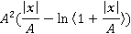 | 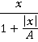

The M-Estimator should fulfill the following constraints:
- Influence function should be bounded.
- Robust estimator should be unique; i.e. the objective function should have a unique minimum.
- The influence function ω(x)≠0 when d ω(x)/dx=0
Huber's function is a parabola in the vicinity of zero, and increases linearly at a given level |x| > k .The value k for the Huber estimator is called a tuning constant; smaller values of k produce more resistance to outliers, but at the expense of lower efficiency when the errors are normally distributed. The tuning constant is generally picked to give reasonably high efficiency in the normal case; in particular, k = 1.345 for the Huber produces 95-percent asymptotic efficiency when the errors are normal, and still offer protection against outliers.
Asymptotic efficiency on the standard normal distribution is the ratio of the variance-covariance matrix of a given estimator to that of the least-squares in the presence of Gaussian noise in the data.
Cauchy's function, also known as the Lorentzian function, does not guarantee a unique solution. With a descending first derivative, such a function has a tendency to yield erroneous solutions in a way which cannot be observed. The 95% asymptotic efficiency on the standard normal distribution is obtained with the tuning constant c = 2.3849. The other remaining functions have the same problem as the Cauchy function. As can be seen from the influence function, the influence of large errors on the data only decreases linearly with their size. The Geman-McClure and Welsh functions try to further reduce the effect of large errors. The 95% asymptotic efficiency on the standard normal distribution of the Welsch function, with c = 2.9846.
However, in our experiments, we found that the Cauchy M-estimator worked really well for tuning parameter less than 2, which we have hence forward used.

4.2 Application of M-Estimators for FastICA: Our Contribution
The idea of FastICA supporting almost any cost function for its algorithm amused us to experiment with the set of M-estimator functions as the cost function for FastICA, along with the fact that M-Estimators are very robust against outliers, which is a required property of cost functions for FastICA, as specified in [2].In our study, we consider four M-Estimators, defined in Table I as cost function for FastICA [9]
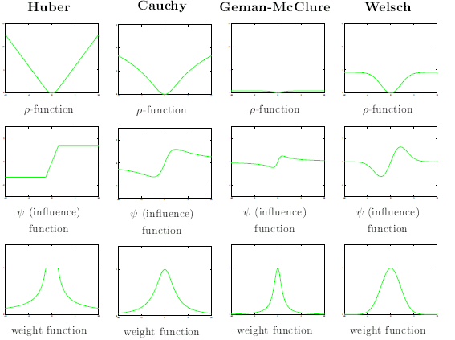
Figure 4: Graph Representation of Common M-Estimators [21]
The values ‘k_{huber} ’, ‘c_{k} ‘ and ‘c’ acts as a tuning constant over which the estimation occurs. Huber’s function has a linear shape above the tuning constant ‘k_{huber}’, but has a parabolic shape below ‘k_{huber}’, in the vicinity of zero. These functions can considerably reduce or even eliminate the influence of outliers. The advantage of using the influence function of M- Estimators for FastICA Algorithm is that the algorithm becomes simple, using simple multiplication, addition and relational operations. Also, Huber’s M-Estimator has already been studied in [7] and seems to be a likely candidate as a cost function. Welsch’s M-Estimator is very similar to the practical cost function given in [2], and therefore has been chosen as a candidate as well. A flowchart representing the implementation of the FastICA is shown below. Our aim is to compare the M-Estimators as cost function for the FastICA Algorithm. The M-Estimators and their Influence functions are used as g and g’ in step 2 of FastICA Algorithm.
Our analysis would be to compare the Amari Performance, Failure to Convergence as well as the Average number of Iterations taken by the M-Estimators, as well as other pre-defined cost functions in FastICA.
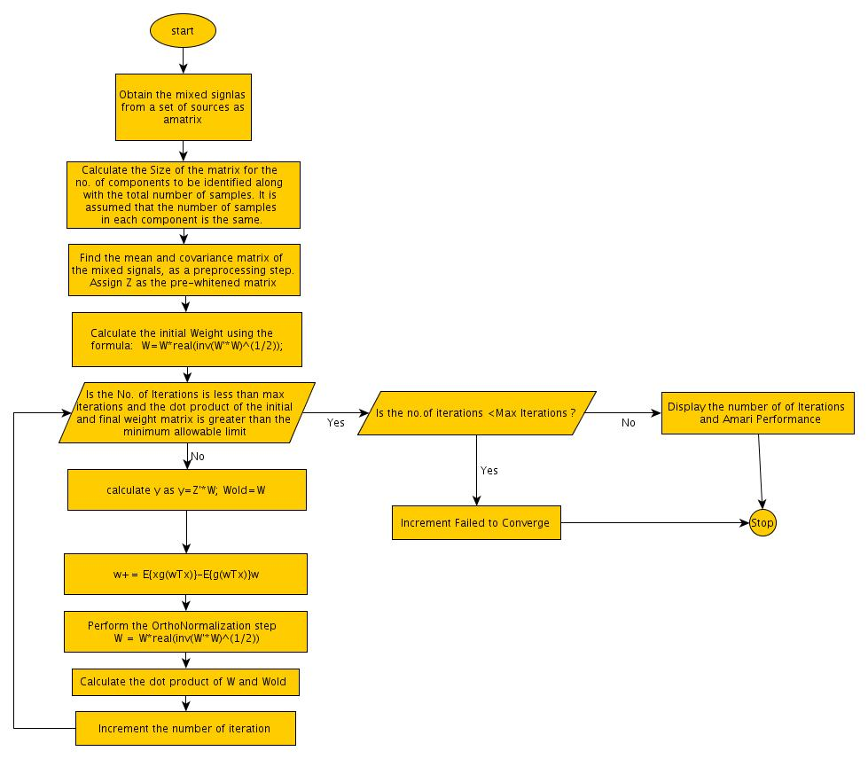
Figure 5: Flowchart for the Code to be implemented

6. CODING AND SIMULATION

5.1 Coding
FastICA uses the following method for separating independent components:
- Identify the number of mixed signals and the number of samples in each observed signal. We have assumed that the number of samples is the same for each signal, though FastICA also allows the provision in which the samples are different. To cope up with that issue, it is recommended to append zero – signal in signals with lesser samples
- Perform pre -processing and whitening:
As explained earlier, pre-processing is a very important factor in FastICA.

Pre-processing allows sphering and whitening data. Sphering means that the observed vector x is linearly transformed into another vector v whose covariance matrix is Unity, i.e. E{vv^{T} }=I.
Pre-processing also allows us to identify the actual number of components present in the observed data.
Pre-processing also involves modifying the observed signal, so that it is centered. This brings the observed signals as close to the unit variance as possible.
In our code, we have used centering the data, as well multiplying the centered value with the square root of covariance of the observed data to whiten the data. (Appendix A)
- Orthogonal Transformation
Sphering alone cannot identify the independent components present in the data. An orthogonal transformation is necessary to be performed, to identify the actual independent components present in the observed signals.
- Convergence of the Algorithm:
Convergence of the algorithm depends on two factors:
- The number of iterations should be less than the maximum eligible value.
- The dot product between current and previous weight matrix should be less than the minimum threshold value. The threshold value in our code is denoted by epsilon and its value in our experiment is 0.0001. The dot product is compared with epsilon, to determine if both the weight matrices point in the same direction. If so, then at that point, the Negentropy is at its maximum value and the estimated signals closely resemble the actual signals.
- Tuning Parameter:
Some M-Estimators need tuning parameter to generate effective results. These tuning
Parameters have different value ranges. For example, while Huber, Cauchy and Fair M-estimators work well for values between (0, 2], Welsch is used for values between (0, 3].
- Performance Measurement:
Fast ICA uses different performance factors which can give a detailed measurement of the separation capability of the algorithm. Some of the common performance indexes used, as mentioned in [22] are:
- Crosstalk and Signal to Noise Ratio: While crosstalk basically identifies the impact of a signal s₂ on the measured signal s₁, Signal to Noise Ratio identifies the amount of noise present in the actual signal. Crosstalk is considered as an inverse of the SNR, and both SNR and Crosstalk are calculated on the basis of the original sources. So they can be used for simulated signals, but not for real – world examples, where the original signals may not be easily obtained.
- Amari Performance Index: The Amari performance index does not depend on permutation and scaling which affect the estimated sources, when they are compared with original sources. Amari Performance Index calculates Cross-Talk error, using the Global Matrix(Global Matrix G=B.A, A is the Mixing matrix and B is the Demixing matrix)
- Comon Performance Index: Similar to Amari Performance index, it only differs in the way the performance is calculated.
- Mean Rejection Level: It is the mean power of the interference of the j^{th} source on the i^{th} signal.
- Error Norm: Error Norm is the matrix of norm of the difference between Actual and Estimated Mixing Matrix.
In our experiments, we have used the Amari performance Index, because of its easier calculation, and wide usage, along with independence of the index from the original signal source. It can also be used very easily on the Real-World Signals.

Following is a snapshot of the code which we have used in our experiment. For the complete code, please see Appendix A.
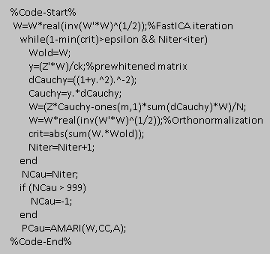
Figure 6: Code Snapshot

5.2 Simulation
Verification of our algorithm is done on 2 levels. We have first verified the performance of algorithm on simulated signals. For this we have taken 3 zero-mean signals, as shown in figure X.
The simulated signals consist of one Saw tooth function, one binary function and one function ranging from -√3to √3.
On mixing these signals, the following mixed signal, shown in Fig. 7(b) may be observed. The simulation is done by arbitrarily mixing the signals using a random mixing matrix along with the effect of a random (gaussian) noise on the signals. The performance of the algorithm is evaluated by checking the behavior assuming random gaussian noise is affecting the signal. Noise is assumed to range from 20dB to +20dB.
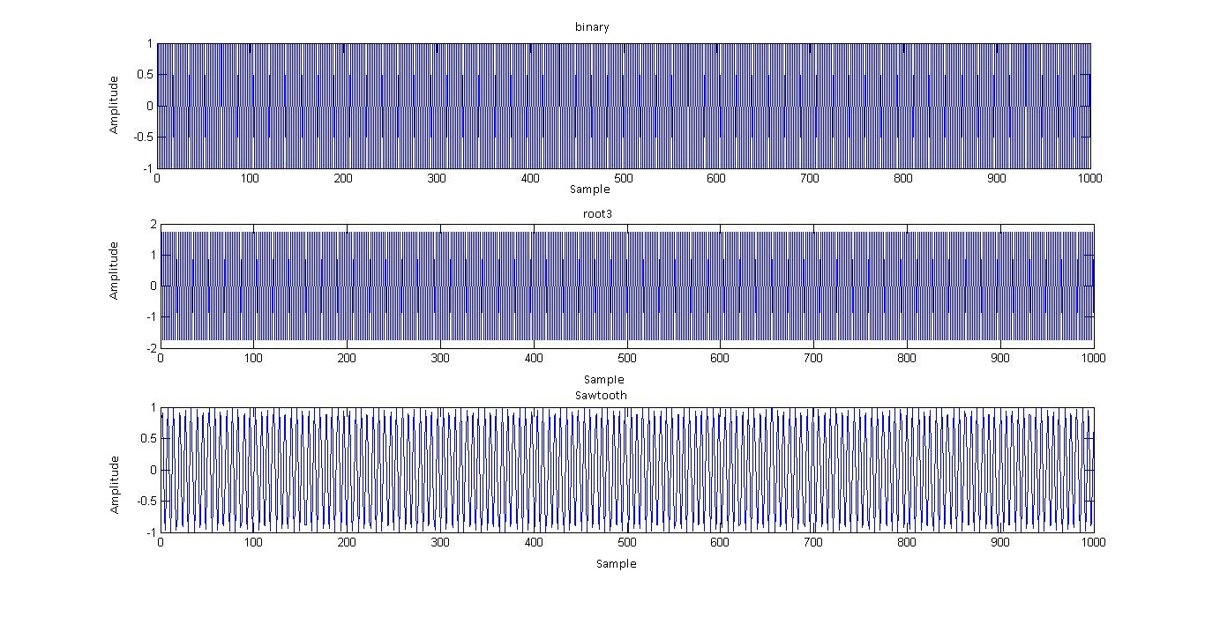
Figure 7(a): Normal Signals
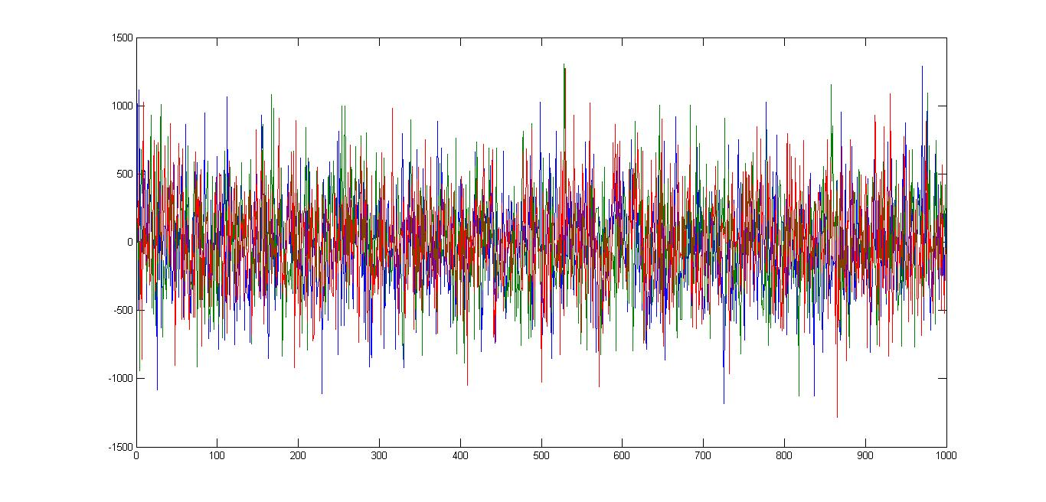Figure 7(b): Mixed Signals
After executing the modified FastICA algorithm for M-Estimators for the simulated signals, the results have been observed and denoted by Figure 8.
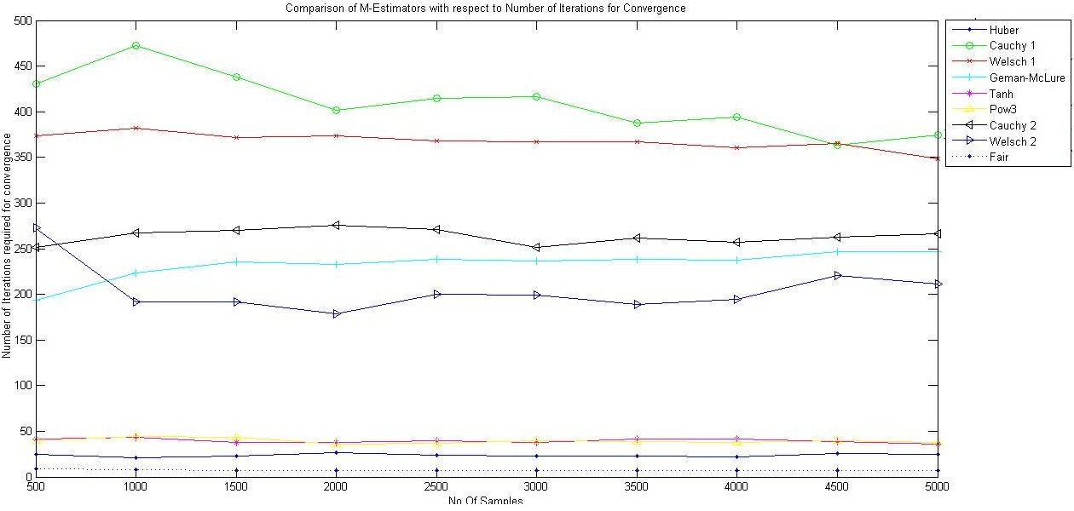
Figure 8 (a): Performance of M-Estimators in terms of Overall Number of iterations
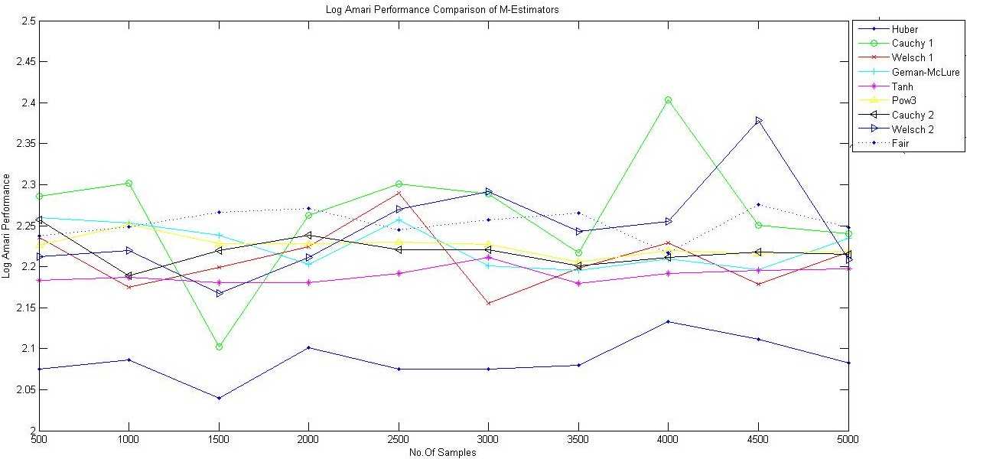
Figure 8 (b): Performance of M-Estimators in terms of Log Amari Performance Index
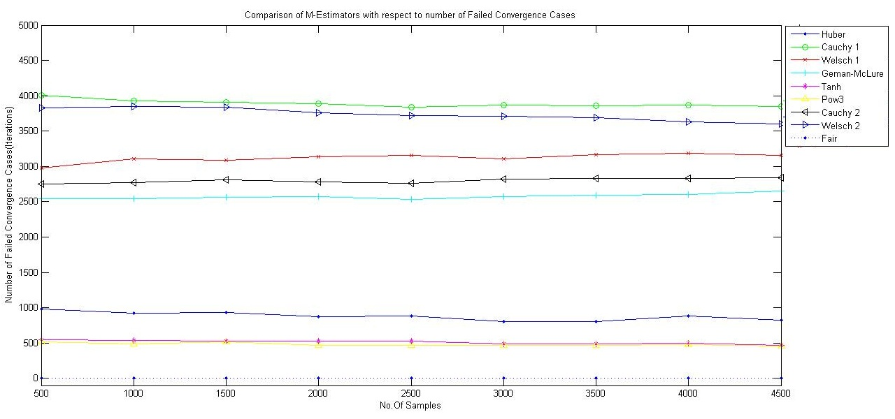
Figure 8 (c): Performance of M-Estimators in terms of Failure to Convergence.
As can be observed in Figure 8(a), Tanh, Pow3, Huber and Fair take very few iterations for convergence, while Cauchy and Welsch perform very poorly. Geman-McLure shows average performance. As per Figure 8(b), Tanh and Huber show excellent separation performance as compared to other M-Estimators.
From Figure 8(c ), we can observe that Pow3 and Tanh show very less Failure to Convergence, while Fair has the least number of Failure to Convergence case, meaning that it is almost guaranteed to converge in most of the cases, even better than tanh and pow3
Next, we executed the algorithm on real -world signals. For this we have used speech signals from http: //research.ics.tkk.fi/ica/cocktail/cocktail_en.cgi . The results for the same are tabulated in Table II.
Isme humein fair ko run karkna padhega
- Comparison of various non-linearites in fastica for speech signals
No. of mixed Source Signal | Huber | C₁ | W₁ | GM | Tanh | pow3 | C₂ | W₂ | Fair
No. of mixed Source Signal | N,F | N,F | N,F | N,F | N,F | N,F | N,F | N,F
2 | 0.030,0 | 1.864,49 | 6.034,14 | 2.510,0 | 0.030,0 | 0.030,0 | 2.415,1 | 0.888,2
3 | 0.041,0 | 0.960,59 | 2.707,39 | 1.699,1 | 0.041,0 | 0.051,0 | 0.901,9 | 0.961,5
4 | 0.040,0 | 4.591,83 | 4.476,70 | 3.552,16 | 0.040,0 | 0.050,0 | 3.817,24 | 3.957,16
5 | 0.061,0 | 7.748,98 | 10.469, 98 | 11.354, 82 | 0.040,0 | 0.050,0 | 9.556,80 | 6.446,63 | 4.3863,0
6 | 0.051,0 | 0.00,100 | 0.000, 100 | 9.714,91 | 0.061,0 | 0.071,0 | 3.073,92 | 7.717,70
7 | 0.081,0 | 0.00,100 | 0.00,100 | 11.332, 93 | 0.051,0 | 0.061,0 | 30.907, 96 | 8.460,80
8 | 0.051,0 | 0.00,100 | 0.00,100 | 0.00,100 | 0.051,0 | 0.071,0 | 61.250, 99 | 48.525,94

Next we observe the behavior of individual M-Estimators with changes in their tuning parameters. Tuning parameters help the M-Estimators to react properly to any effect of outliers. Each M-Estimator is effected differently by its tuning constant. Here we study the effect of changes in tuning parameter on Cauchy, Fair, Huber and Welsch M-Estimator respectively.
For this, we have used a mixture of simulated source signals, consisting of the binary, root3 and saw-tooth function values, mixed with Gaussian noise. The source signals have 100-500 samples, thus providing us with a set of 5 sources. The different sample size helps us in identifying the properties of the individual M-Estimators.
- Cauchy M-Estimator:
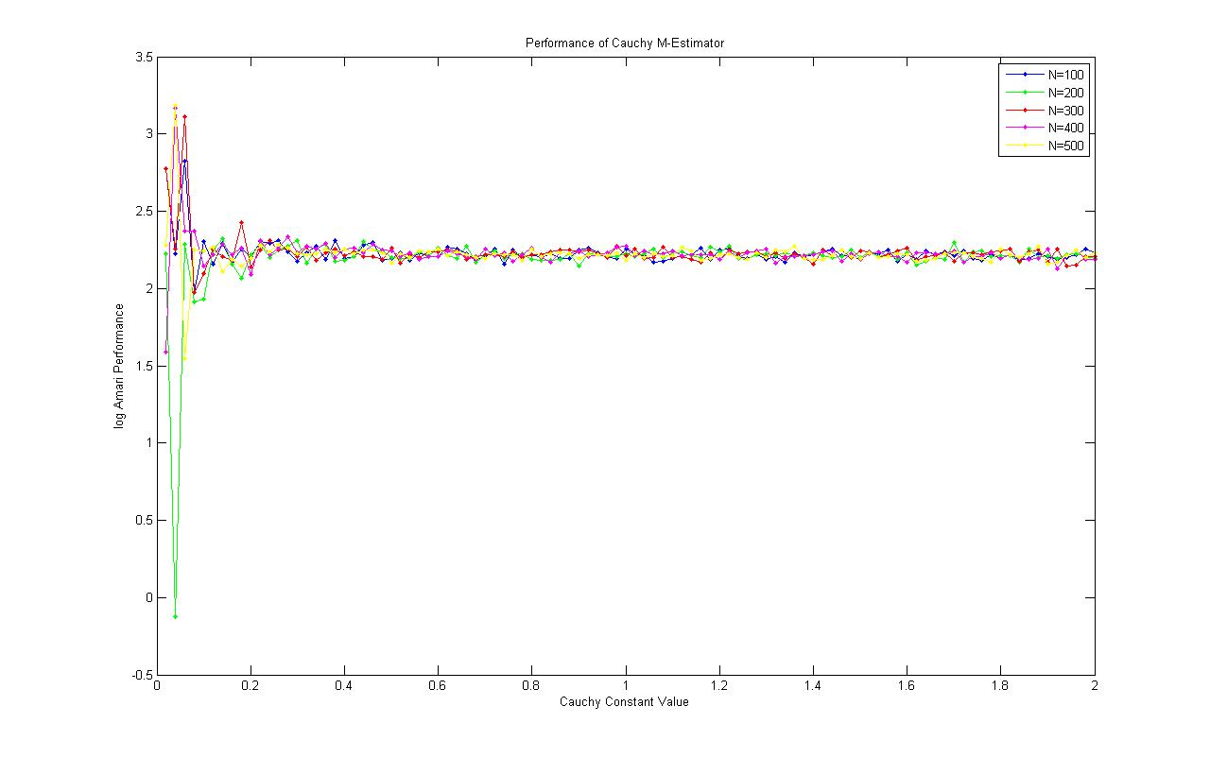
Figure 9(a): Log Amari Performance of Cauchy M-Estimator with change in tuning parameter
From Figure 9 (a), we can understand that the Amari Performance Index for Cauchy M-Estimator does not vary widely with the number of samples, as the tuning parameter is changed. The Amari Performance Index deviates a lot for tuning value<0.2, but from 0.2 to 2, the Amari Performance Index is nearly constant for all sample sizes.
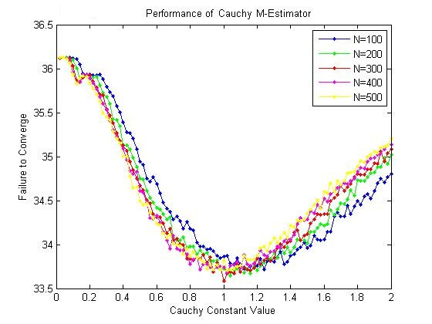
Figure 9(b): Failure to Converge of Cauchy M-Estimator with change in tuning parameter
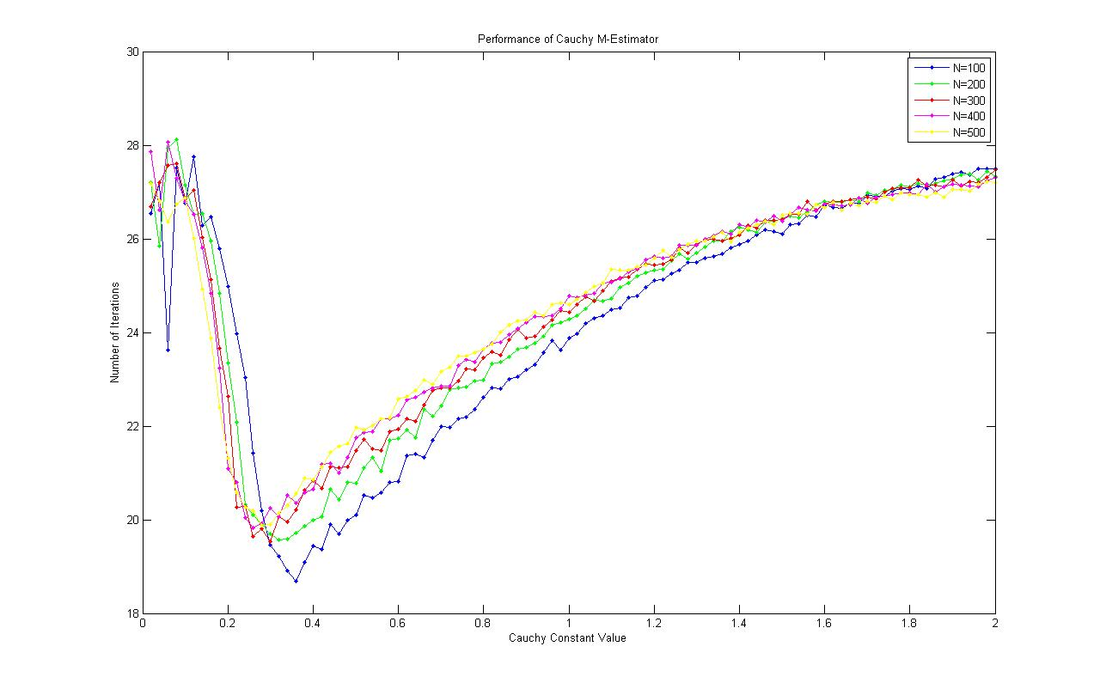
Figure 9(c): Number of Iterations to Converge for Cauchy M-Estimator with change in tuning parameter
Figure 9(b) highlights the Convergence Failure of Cauchy M-Estimator with change in the tuning parameter. We can observe a global minima at tuning parameter=1 after a local minima near 0.2 .With increase in the Tuning Parameter value, the Failure to Convergence decreases till 1, after which it rises back. This behavior is notable and nearly consistent across all sample sizes.
Figure 9(c ) shows that after a local minima between 0.2 to 0.4, the number of iterations needed to converge increase, though the increase is not very fast, with a decreasing slope with increase in the tuning constant value.
The important point to be noted is that Cauchy behaves almost similarly for all sample sizes and there is not much deviation observed for different sample sizes.
- Huber M-Estimator:
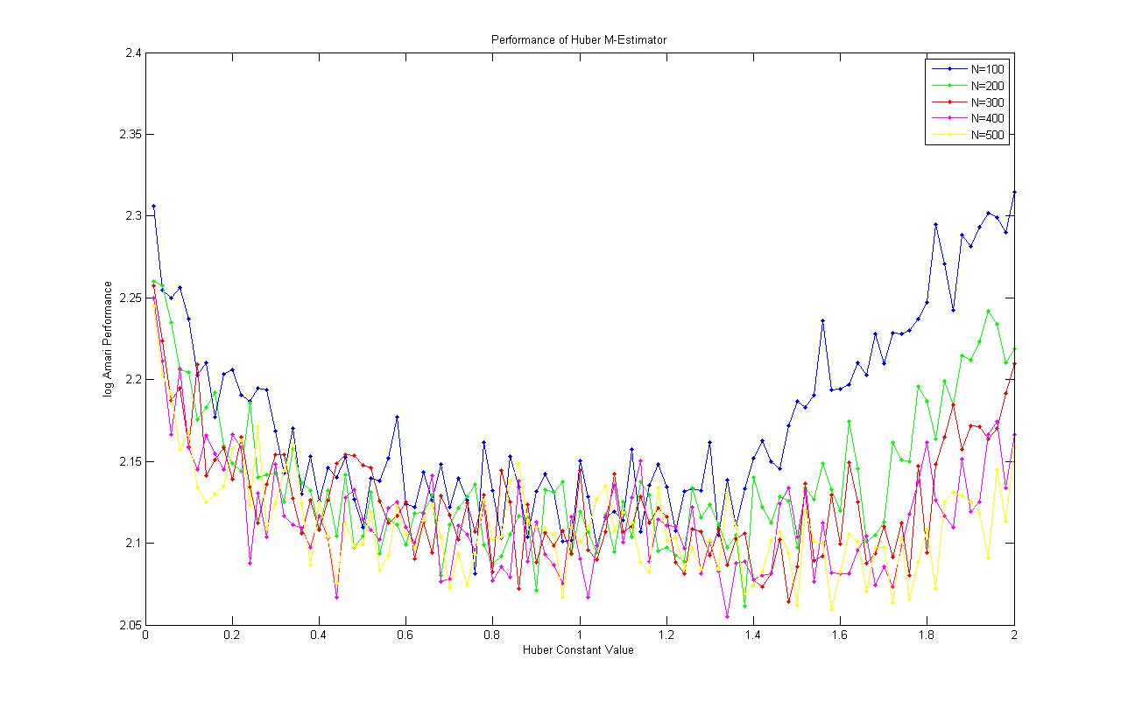
Figure 10(a): Amari Performance Index of Huber M-Estimator with change in tuning parameter

In Huber M-Estimator, the Amari Performance Index has local minima between 0.8 and 1. However, unlike Cauchy, the sample sizes in Huber do not show identical behavior, with N=100 having a larger parabolic shape than N=500.

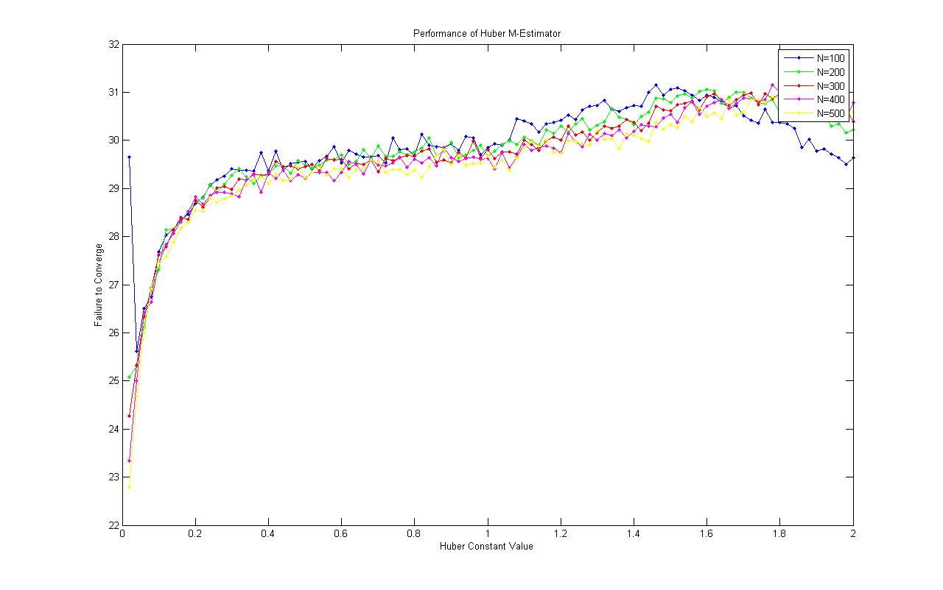 Figure 10(b): Convergence Failure of Huber M-Estimator with change in tuning parameter
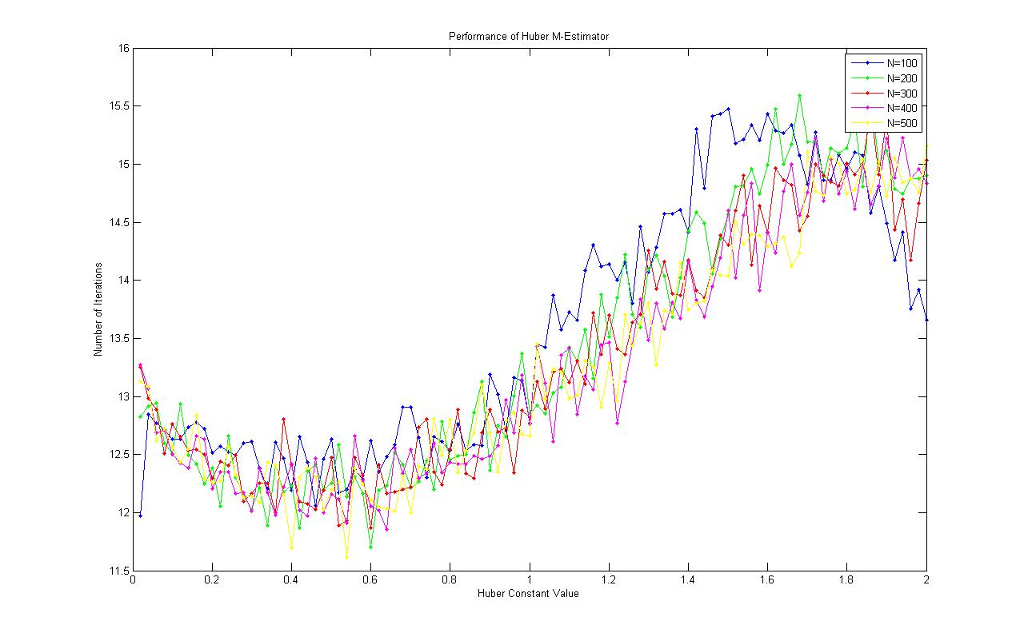Figure 10(c ): Number of Iterations for Convergence of Huber M-Estimator with change in tuning parameter

Figure 10(b) shows that the Failure to Converge increases with increase in tuning constant value, though the slope of the curve is constantly decreasing , with sample size N=100 nearly reversing direction and infact showing a decrease in the number of Failure cases near constant value=2, while the other sample size nearing 0 slope at that point.
Figure 10(c ) shows that there is a minima near 0.4-0.6, and a maxima near 1.4-1.8. The number of iterations decrease from 0-0.2, starts to increase from 0.2 -1.8, and then decrease back.
The behavior as noted for Huber M-Estimator is significantly displayed for N=100 and the behavior is less and less prominent with increase in the sample size. This is unlike Cauchy, where the behavior is almost consistent for all sample sizes.
- Fair M-Estimator
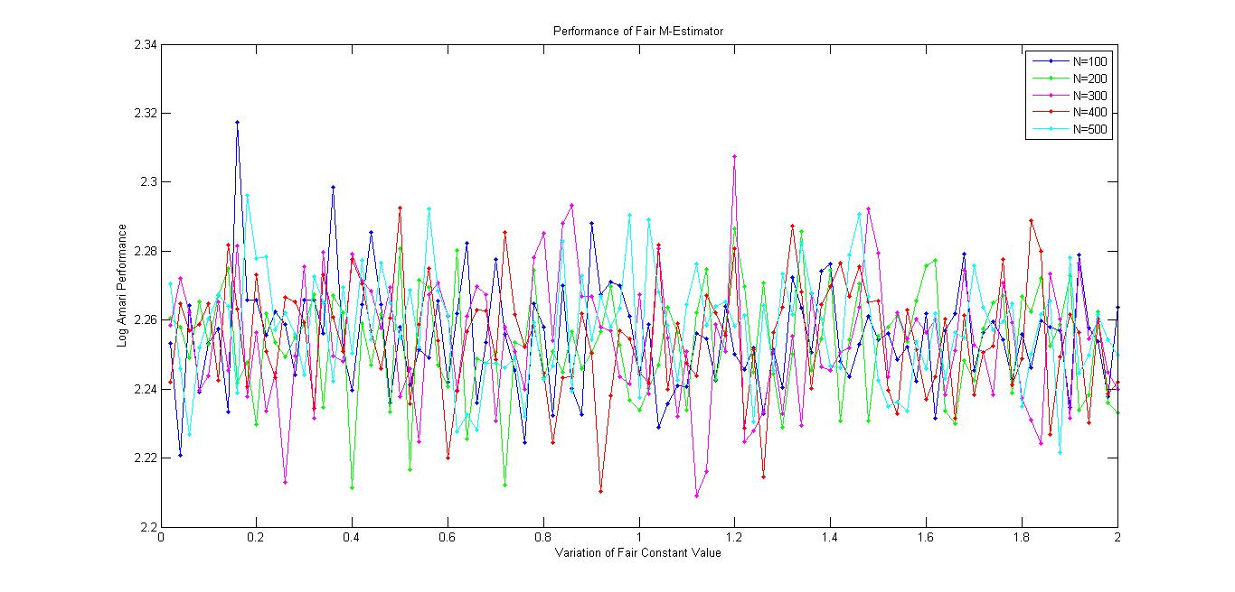
Figure 11(a): Amari Performance Index of Fair M-Estimator with change in tuning parameter

The figure 11(a) shows that there is no deterministic property in the Performance Index of Fair M-Estimator, with change in tuning parameter value. The overall behavior though seems random , the shape is consistent across all sample sizes.
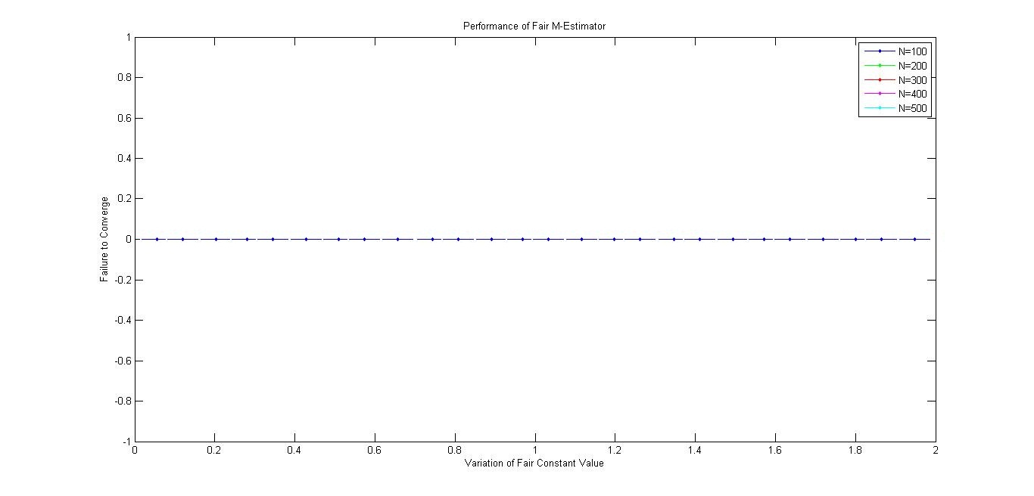
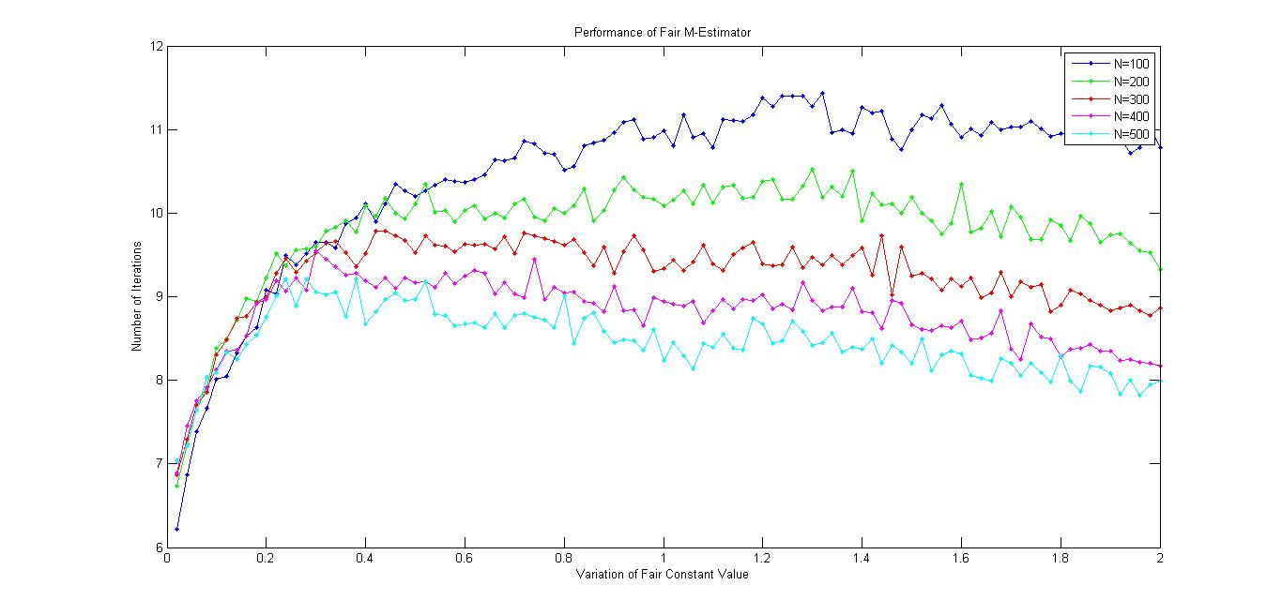
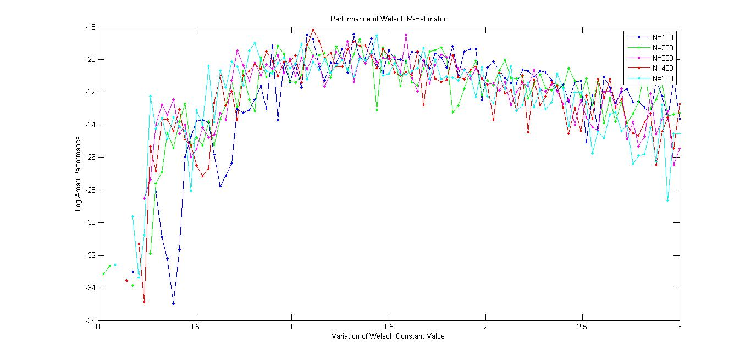

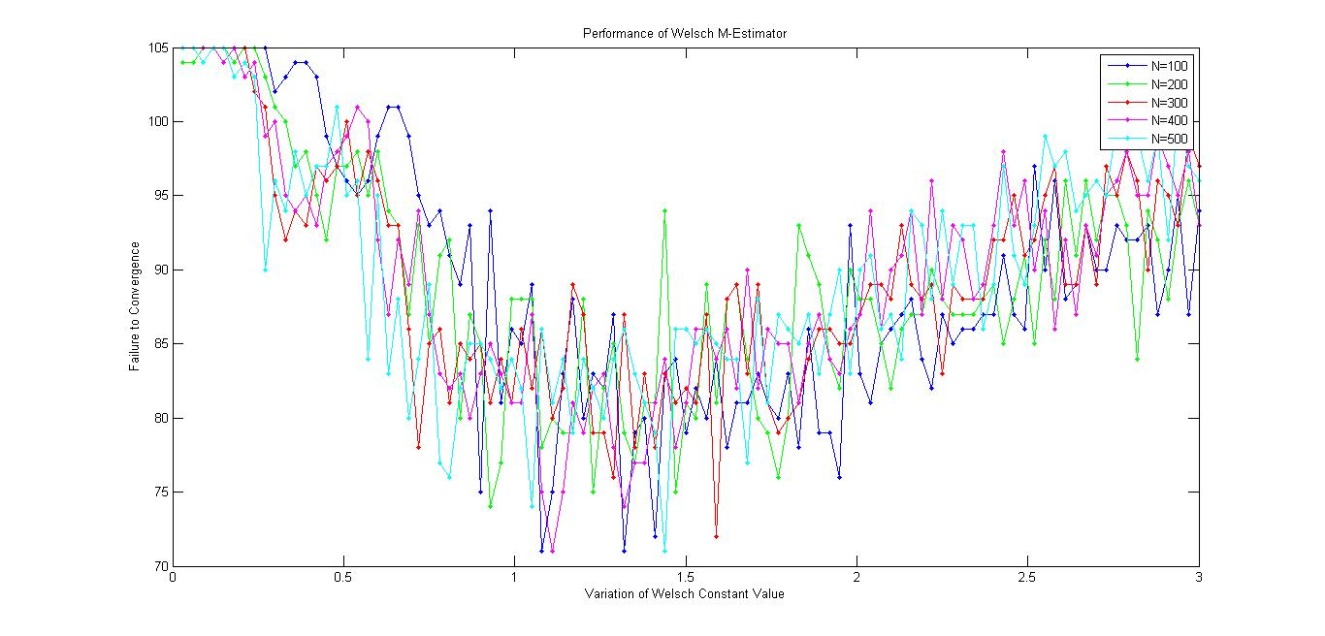
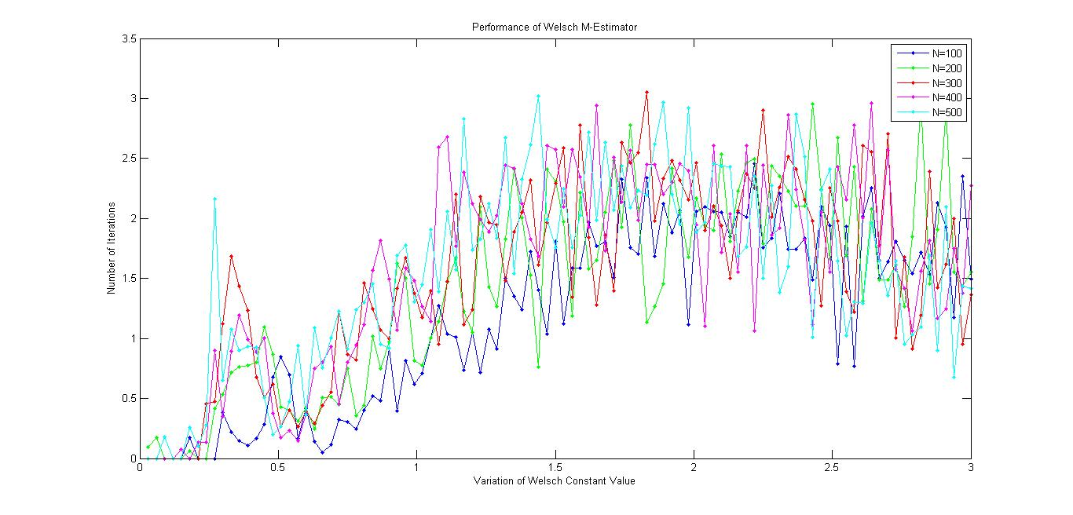

6. REFERENCES
[1]Hyvarinen A. “Independent Component Analysis: Algorithms and Applications”. Neural Networks, 2000, 13:411-43
[2] Malay Gupta and Scott C.Douglas, “Signal deflation and Paraunitary constraints in Spatio-Temporal FastICA- based Convolutive Blind Source Separation of speech mixtures”, 2007,IEEE Workshop on Applications of Signal Processing to Audio and Acoustics.
[3] Li Hongyan and Ren Guanglong ,“Blind separation of noisy mixed speech signals based Independent Component Analysis “,2010, First International Conference on Pervasive Computing, Signal Processing and Application
[4] Hongyan Li, Huakui Wang, Baojin Xiao “Blind separation of noisy mixed speech signals based on wavelet transform and Independent Component Analysis”,ICSP2006 Proceedings
[5] Hiroki Asari, Barak A. Pearlmutter, and Anthony M. Zador,”Sparse Representations for the Cocktail Party Problem”,The Journal of Neuroscience, July 12, 2006
[6] Hyvarinen, A., Karhunen, J., Oja, E.: Independent Component Analysis. John Wiley & Sons, New York (2001)
[7] Zahooruddin,Farooq Alam Orakzai,"Hardware implementation of blind source separation of speech signals using independent component analysis",International Journal of Electrical & Computer Sciences IJECS-IJENS Vol: 10 No: 01
[8]Scott C. Douglas, Malay Gupta,Hiroshi Sawada, and Shoji Makino“Spatio–Temporal FastICA Algorithms for the Blind Separation of Convolutive Mixtures “ IEEE transactions on Audio,Speech,and Language Processing, Vol. 15, No.5, July 2007
[9] Zbynˇek Koldovský, Petr Tichavský, and Erkki Oja,” Efficient Variant of Algorithm FastICA for Independent Component Analysis Attaining the Cramér-Rao Lower Bound”
[10] Hyvarinen, A. and Oja, E,”A Fast Fixed Point Algorithm for Independent Component Analysis”,Neural Computation,1997
[11] Ella Bingham and Aapo Hyv¨arinen” A Fast Fixed-Point Algorithm For Independent Component Analysis of Complex Valued Signals”, International Journal of Neural Systems, Vol. 10, No. 1 (February, 2000)
[12]Malaya K. Nath,”Independent Component Analysis of Real Data “2009 Seventh International Conference on Advances in Pattern Recognition
[13] Aapo Hyvarein ,”Fast and Robust Fixed –Point Algorithms for Independent Component Analysis “
[14] Aapo Hyvärinen and Erkki Oja ,“Independent Component Analysis:Algorithms and Applications”, Neural Networks, 13(4-5):411-430, 2000
[15] Chao,Jih-Cheng and Douglas,Scott C.,”A Simple and Robust FastICA Algorithm using the Huber M-Estimator Cost Function”,ICASSP,2006.
[16] ROLAND WINKLER, FRANK KLAWONN, RUDOLF KRUSE,”Fuzzy Clustering with Polynomial Fuzzifier function in connection with M-Estimators”, Appl. Comput. Math., V.10, N.1, Special Issue, 2011, pp.146-163
[17]Robust Estimation of a Location Parameter,Peter J. Huber ,Annals of Mathematical Statistics; Volume 35, Number 1 (1964), 73-101.
[18] John Fox, “Robust Regression,Appendix to An R and S-PLUS Companion to Applied Regression”, January 2002
[19] B. D. Ripley,”M.Sc. in Applied Statistics MT2004”,Robust Statistics,1992–2004
[20] K.V. Arya a,*, P. Gupta b, P.K. Kalra c, P. Mitra d,”Image registration using robust M-estimators”, Pattern Recognition Letters 28 (2007) 1957–1968
[21] Zhengyou Zhang, Parameter Estimation Techniques,”A Tutorial with Application to Conic Fitting”, Image and Vision Computing, Vol.15, No.1, pages 59-76, January 1997.
[22] Ali Mansour, Mitsuru Kawamoto & Noboru Ohnishi,”A Survey of The Performance Indexes of ICA Algorithms”, Proceedings of the IASTED International Conference of Modeling, Identification, And Control, February 18-21, 2002, Innsbruck, Austria

7. APPENDIX – A: COMPLETE SOURCE CODE
We have evaluated the modified FastICA algorithm in 2 different test cases.
- The first case involves overall comparison of the algorithm for simulated and real world signals. Here we are presenting only the simulated algorithm. For real world samples, the only change would be in the creation of the mixed signals. The main logic is the same.
- The second case studies the behavior of the algorithm on the simulated signals, as the tuning constants of Huber, Cauchy, Welsch and Fair are modified.
We present the source codes in the same format as the above defined test cases, with the first case in Section I and second in Section II.
The main M-Estimator based FastICA Algorithm source codes are defined in Section III. Section IV highlights the other source files used during our experimentation.

I.Overall Evaluation of M-Estimators
%File-Name:Perf-fair.m%
%M-Estimator-Evaluation-Function%
function [N_output,A_output,F_output]=perf_fair()
nsamples=500;
N_output=zeros(10,9);
A_output=zeros(10,9);
F_output=zeros(10,9);
while(nsamples<5001)
empty=0;
Np=0;
Ap=0;
f2cp=0;
Nc1=0;
Ac1=0;
f2cc1=0;
Nw1=0;
Aw1=0;
f2cw1=0;
Ng=0;
Ag=0;
f2cg=0;
Nt=0;
At=0;
f2ct=0;
Nh=0;
Ah=0;
f2ch=0;
Nc2=0;
Ac2=0;
f2cc2=0;
Nw2=0;
Aw2=0;
f2cw2=0;
Nf=0;
Af=0;
f2cf=0;
s1=binary(nsamples);
s2=root3(nsamples);
s3=signal(nsamples);
s=[s1;s2;s3];
fprintf('Calculating %d samples\n',nsamples);
for SNRlevel = -20:20
fprintf('Calculating %d Noise\n',SNRlevel+21);
for i = 1:100
fprintf('Calculating %d Iteration\n',i);
w=eye(3);%10 random weights
A = 2*rand(3)-1;
x = (A*s)';
n = randn(nsamples,3);
varn = sumsqr(n);
vary = sumsqr(x);
n = n/varn*vary/10^(SNRlevel/10);
x = x + n;
[N,m]=size(x);
[N1,A1]=Hbr(N,m,x,w,A);
if (N1 ~= -1)
Nh=Nh+N1;
Ah=Ah+A1;
else
f2ch=f2ch+1;
end
[N2,A2]=cau(N,m,x,w,A);
if (N2 ~= -1)
Nc1=Nc1+N2;
Ac1=Ac1+A2;
else
f2cc1=f2cc1+1;
end
[N3,A3]=wel(N,m,x,w,A);
if (N3 ~= -1)
Nw1=Nw1+N3;
Aw1=Aw1+A3;
else
f2cw1=f2cw1+1;
end
[N4,A4]=gm(N,m,x,w,A);
if (N4 ~= -1)
Ng=Ng+N4;
Ag=Ag+A4;
else
f2cg=f2cg+1;
end
[N5,A5]=htan(N,m,x,w,A);
if (N5 ~= -1)
Nt=Nt+N5;
At=At+A5;
else
f2ct=f2ct+1;
end
[N6,A6]=pow3(N,m,x,w,A);
if (N6 ~= -1)
Np=Np+N6;
Ap=Ap+A6;
else
f2cp=f2cp+1;
end
[N7,A7]=cau1(N,m,x,w,A);
if (N7 ~= -1)
Nc2=Nc2+N7;
Ac2=Ac2+A7;
else
f2cc2=f2cc2+1;
end
[N8,A8]=wel1(N,m,x,w,A);
if (N8 ~= -1)
Nw2=Nw2+N8;
Aw2=Aw2+A8;
else
f2cw2=f2cw2+1;
end
[N9,A9]=fair(N,m,x,w,A);
if (N9 ~= -1)
Nf=Nf+N9;
Af=Af+A9;
empty=empty+1;
else
f2cf=f2cf+1;
end
end
end
empty
%TOTAL ITERATIONS=4100.FAILED TO CONVERGE IS CALUCLATED FROM THIS.
if (f2ch ~= 4100)
N_output((nsamples/500),1)=(Nh/(4100- f2ch));
A_output((nsamples/500),1)=(Ah/(4100- f2ch));
F_output((nsamples/500),1)=f2ch;
end
if(f2cc1 ~= 4100)
N_output((nsamples/500),2)=(Nc1/(4100 - f2cc1));
A_output((nsamples/500),2)=(Ac1/(4100 - f2cc1));
F_output((nsamples/500),2)=f2cc1;
end
if(f2cw1 ~= 4100)
N_output((nsamples/500),3)=(Nw1/(4100 - f2cw1));
A_output((nsamples/500),3)=(Aw1/(4100 - f2cw1));
F_output((nsamples/500),3)=f2cw1;
end
if(f2cg ~= 4100)
N_output((nsamples/500),4)=(Ng/(4100 - f2cg));
A_output((nsamples/500),4)=(Ag/(4100 - f2cg));
F_output((nsamples/500),4)=f2cg;
end
if(f2ct ~= 4100)
N_output((nsamples/500),5)=(Nt/(4100 - f2ct));
A_output((nsamples/500),5)=(At/(4100 - f2ct));
F_output((nsamples/500),5)=f2ct;
end
if(f2cp ~= 4100)
N_output((nsamples/500),6)=(Np/(4100 - f2cp));
A_output((nsamples/500),6)=(Ap/(4100 - f2cp));
F_output((nsamples/500),6)=f2cp;
end
if(f2cc2 ~= 4100)
N_output((nsamples/500),7)=(Nc2/(4100 - f2cc2));
A_output((nsamples/500),7)=(Ac2/(4100 - f2cc2));
F_output((nsamples/500),7)=f2cc2;
end
if(f2cw2 ~= 4100)
N_output((nsamples/500),8)=(Nw2/(4100 - f2cw2));
A_output((nsamples/500),8)=(Aw2/(4100 - f2cw2));
F_output((nsamples/500),8)=f2cw2;
end
if(f2cf ~= 4100)
N_output((nsamples/500),9)=(Nf/(4100 - f2cf));
A_output((nsamples/500),9)=(Af/(4100 - f2cf));
F_output((nsamples/500),9)=f2cf;
end
csvwrite('N_output.csv',N_output);
csvwrite('A_output.csv',A_output);
csvwrite('F_output.csv',F_output);
nsamples=nsamples+500;
end
%Code-End%

II.Evalutaion of M-Estimator with changing tuning constant
function [N_output,A_output,F_output]=perf_fair_f()
N_output=zeros(100,5);
A_output=zeros(100,5);
F_output=zeros(100,5);
c=0.0;
t=0;
while(c<2.0)
nsamples=100;
c=c+0.02;
t=t+1;
fprintf('Calculating for c=%d',c);
while(nsamples<501)
Nf=0;
Af=0;
f2cf=0;
s1=binary(nsamples);
s2=root3(nsamples);
s3=signal(nsamples);
s=[s1;s2;s3];
fprintf('Calculating %d samples\n',nsamples);
for SNRlevel = -20:20
fprintf('Calculating %d Noise\n',SNRlevel+21);
for i = 1:100
fprintf('Calculating %d Iteration\n',i);
w=eye(3);%10 random weights
A = 2*rand(3)-1;
x = (A*s)';
n = randn(nsamples,3);
varn = sumsqr(n);
vary = sumsqr(x);
n = n/varn*vary/10^(SNRlevel/10);
x = x + n;
[N,m]=size(x);
[N9,A9]=fair(N,m,x,w,A,c);
if (N9 ~= -1)
Nf=Nf+N9;
Af=Af+A9;
else
f2cf=f2cf+1;
end
end
end
if(f2cf ~= 4100)
N_output(t,(nsamples/100))=(Nf/(4100 - f2cf));
A_output(t,(nsamples/100))=(Af/(4100 - f2cf));
F_output(t,(nsamples/100))=f2cf;
end
csvwrite('N_output.csv',N_output);
csvwrite('A_output.csv',A_output);
csvwrite('F_output.csv',F_output);
nsamples=nsamples+100;
end
end

III.M-Estimator based FastICA Algorithms
%File-Name:cau1.m%
%Cauchy I: Contant Value:
function [NCau,PCau]=cau1(N,m,s,W,A)
o=(s'-mean(s',2)*ones(1,N))';%preprocessing part I
epsilon=0.0001;
iter=1000;
Niter=0;
crit=zeros(1,N);
C=cov(o);
CC=C^(-1/2);
Z=CC*o';%Preprocessing part II
%ck=0.225+(2.05-0.225)*rand;%Randomly Generated Cauchy COnstant
ck=0.225+(2.05-0.225)*rand;%Randomly Generated Cauchy COnstant
W=W*real(inv(W'*W)^(1/2));%FastICA iteration
while(1-min(crit)>epsilon && Niter<iter)
Wold=W;
y=(Z'*W)/ck;%prewhitened matrix
dCauchy=((1+y.^2).^-2);
Cauchy=y.*dCauchy;
W=(Z*Cauchy-ones(m,1)*sum(dCauchy)*W)/N;
W=W*real(inv(W'*W)^(1/2));%Orthonormalization
crit=abs(sum(W.*Wold)); %chnaged here from W.*
Niter=Niter+1;
end
NCau=Niter;
if (NCau > 999)
NCau=-1;
end
PCau=AMARI(W,CC,A);
%Code-End%

%File Name:gm.m%
function [NGM,PGM]=gm(N,m,s,W,A)
o=(s'-mean(s',2)*ones(1,N))';%preprocessing part I
epsilon=0.0001;
iter=1000;
Niter=0;
crit=zeros(1,N);
C=cov(o);
CC=C^(-1/2);
Z=CC*o';%Preprocessing part II
W=W*real(inv(W'*W)^(1/2));%FastICA iteration
while(1-min(crit)>epsilon && Niter<iter)
Wold=W;
y=Z'*W;%prewhitened matrix
GM=y.*((1+y.^2).^-2);
dGM=((1+y.^2).^-2);
W=(Z*GM-ones(m,1)*sum(dGM)*W)/N;
W=W*real(inv(W'*W)^(1/2));%Orthonormalization
crit=abs(sum(W.*Wold)); %chnaged here from W.*
Niter=Niter+1;
end
NGM=Niter;
if (NGM > 999)
NGM=-1;
end
NGM=Niter;
if (NGM > 999)
NGM=-1;
end
PGM=AMARI(W,CC,A);
%Code-End%

%File-Name:fair.m%
function [Nfair,Pfair]=fair(N,m,s,W,A)
c=1.3998;
o=(s'-mean(s',2)*ones(1,N))';
epsilon=0.0001;
iter=1000;
Niter=0;
crit=zeros(1,N);
C=cov(o);
CC=C^(-1/2);
Z=CC*o';
W=W*real(inv(W'*W)^(1/2));%FastICA iteration
while(1-min(crit)>epsilon && Niter<iter)
Wold=W;
y=Z'*W;
dg=(1+(abs(y)/c));
g=y./(dg);
%W=(Z*g'-ones(m,1)*sum(dg)*W)/N;
[W,R]=qr(Z*g - ones(m,1)*sum(dg)*W);
W=W*real(inv(W'*W)^(1/2));%Orthonormalization
crit=abs(sum(W.*Wold)); %chnaged here from W.*
Niter=Niter+1;
%fprintf('%d:',Niter);
end
Nfair=Niter;
if (Nfair > 999)
Nfair=-1;
end
Pfair=AMARI(W,CC,A);
%Code-End%

%File-Name:wel1.m%
function[NWel,PWel]=wel1(N,m,s,W,A)
o=(s'-mean(s',2)*ones(1,N))';%preprocessing part I
epsilon=0.0001;
iter=1000;
Niter=0;
crit=zeros(1,N);
C=cov(o);
CC=C^(-1/2);
Z=CC*o';%Preprocessing part II
%c=2.9846;%Cauchy COnstant
c=0.2399+(0.3-0.24)*rand;
%find out welsch constant on the internet. it is required as it may be used
%in several places and the absoulte value is required for proper
%convergence of the algorithm. We can also do an independent study of how
%the Welsch's constant drives FastICA
W=W*real(inv(W'*W)^(1/2));%FastICA iteration
while(1-min(crit)>epsilon && Niter<iter)
Wold=W;
y=Z'*W;%prewhitened matrix
dWelsch=(exp(-(((y)/c).^2)));
Welsch=y.*dWelsch;
W=(Z*Welsch-ones(m,1)*sum(dWelsch)*W)/N;
W=W*real(inv(W'*W)^(1/2));%Orthonormalization
crit=abs(sum(W.*Wold)); %chnaged here from W.*
Niter=Niter+1;
end
NWel=Niter;
if (NWel > 999)
NWel=-1;
end
PWel=AMARI(W,CC,A);
%Code-End%

%File-Name:htan.m%
function [NTanh,PTanh]=htan(N,m,s,W,A)
o=(s'-mean(s',2)*ones(1,N))';
epsilon=0.0001;
iter=1000;
Niter=0;
crit=zeros(1,N);
C=cov(o);
CC=C^(-1/2);
Z=CC*o';
W=W*real(inv(W'*W)^(1/2));%FastICA iteration
while(1-min(crit)>epsilon && Niter<iter)
Wold=W;
hypTan=tanh(Z'*W);
W=Z*hypTan/N -ones(m,1)*sum(1-hypTan.^2).*W/N;
W=W*real(inv(W'*W)^(1/2));
crit=abs(sum(W.*Wold));
Niter=Niter+1;
end
NTanh=Niter;
if (NTanh > 999)
NTanh=-1;
end
PTanh=AMARI(W,CC,A);
%Code-End%

%File-Name:cau.m%
function [NCau,PCau]=cau(N,m,s,W,A)
o=(s'-mean(s',2)*ones(1,N))';%preprocessing part I
epsilon=0.0001;
iter=1000;
Niter=0;
crit=zeros(1,N);
C=cov(o);
CC=C^(-1/2);
Z=CC*o';%Preprocessing part II
%ck=0.225+(2.05-0.225)*rand;%Randomly Generated Cauchy COnstant
ck=0.0594+(0.1706-0.0594)*rand;
W=W*real(inv(W'*W)^(1/2));%FastICA iteration
while(1-min(crit)>epsilon && Niter<iter)
Wold=W;
y=(Z'*W)/ck;%prewhitened matrix
dCauchy=((1+y.^2).^-2);
Cauchy=y.*dCauchy;
W=(Z*Cauchy-ones(m,1)*sum(dCauchy)*W)/N;
W=W*real(inv(W'*W)^(1/2));%Orthonormalization
crit=abs(sum(W.*Wold)); %chnaged here from W.*
Niter=Niter+1;
end
NCau=Niter;
if (NCau > 999)
NCau=-1;
end
PCau=AMARI(W,CC,A);
%Code-End%

%File-Name:pow3.m%
function [NPow3,PPow3]=pow3(N,m,s,W,A)
o=(s'-mean(s',2)*ones(1,N))';
epsilon=0.0001;
iter=1000;
Niter=0;
crit=zeros(1,N);
C=cov(o);
CC=C^(-1/2);
Z=CC*o';
W=W*real(inv(W'*W)^(1/2));%FastICA iteration
while(1-min(crit)>epsilon && Niter<iter)
Wold=W;
W=(Z*((Z'*W).^3))/N-3*W;
W=W*real(inv(W'*W)^(1/2));
crit=abs(sum(W.*Wold));
Niter=Niter+1;
end
NPow3=Niter;
if (NPow3 > 999)
NPow3=-1;
end
PPow3=AMARI(W,CC,A);
%File-Name:wel.m%
function[NWel,PWel]=wel(N,m,s,W,A)
o=(s'-mean(s',2)*ones(1,N))';%preprocessing part I
epsilon=0.0001;
iter=1000;
Niter=0;
crit=zeros(1,N);
C=cov(o);
CC=C^(-1/2);
Z=CC*o';%Preprocessing part II
%c=2.9846;%Cauchy COnstant
c=1.154+(1.9-1.154)*rand;
%find out welsch constant on the internet. it is required as it may be used
%in several places and the absoulte value is required for proper
%convergence of the algorithm. We can also do an independent study of how
%the Welsch's constant drives FastICA
W=W*real(inv(W'*W)^(1/2));%FastICA iteration
while(1-min(crit)>epsilon && Niter<iter)
Wold=W;
y=Z'*W;%prewhitened matrix
dWelsch=(exp(-(((y)/c).^2)));
Welsch=y.*dWelsch;
W=(Z*Welsch-ones(m,1)*sum(dWelsch)*W)/N;
W=W*real(inv(W'*W)^(1/2));%Orthonormalization
crit=abs(sum(W.*Wold)); %chnaged here from W.*
Niter=Niter+1;
end
NWel=Niter;
if (NWel > 999)
NWel=-1;
end
PWel=AMARI(W,CC,A);
%Code-End%

%file-name:Hbr.m%
function [NHuber,PHuber]=Hbr(N,m,s,W,A)
theta=1.345;
o=(s'-mean(s',2)*ones(1,N))';
epsilon=0.0001;
iter=1000;
Niter=0;
crit=zeros(1,N);
C=cov(o);
CC=C^(-1/2);
Z=CC*o';
W=W*real(inv(W'*W)^(1/2));%FastICA iteration
while(1-min(crit)>epsilon && Niter<iter)
Wold=W;
y=Z'*W;
t=(abs(y)<theta);
g=y.*t + theta * sign(y).*(1-t);
dg=sum(t);
[W,R]=qr(Z*g - W*diag(dg)); %changed here from Z
W=W*real(inv(W'*W)^(1/2));%Orthonormalization
crit=abs(sum(W.*Wold)); %chnaged here from W.*
Niter=Niter+1;
end
NHuber=Niter;
if (NHuber > 999)
NHuber=-1;
end
PHuber=AMARI(W,CC,A);
%Code-End%

IV. Other Code used during Experimentation
%File-Name: Amari.m%
%Calculates the AmariSeperation Performance Index%
function a = AMARI( W,CC,P)
% function a = AMARItest( G)%
% Returns a performance measure based on the system’s global matrix using the AMARI criterion
% Cichocki, A and Amari, S "Adaptive Blind Signal and Image Processing"% John Wiley & Sons 2005 p308
G=W*CC*P;
a = sum(sum(abs(G),2)./max(abs(G),[],2)-1) + sum(sum(abs(G))./max(abs(G))-1);
a = a/size(G,1);
%Code-End%

%File-name:binary.m%
function [ sqrtN ]= binary(N)
sqrtN=ones(1,N);
a=-1;
for i=2:N
sqrtN(i)=sqrtN(i-1).*a;
end
%i=1:1000;
%plot(i,sqrtN)
%axis ( [ 0 100 -1 1 ])

%file-name:root3.m%
function [ sqrtN ]= root3(N)
sqrtN=ones(1,N).*sqrt(3);
a=-1;
for i=2:N
sqrtN(i)=sqrtN(i-1).*a;
end
%i=1:1000;
%plot(i,sqrtN)
%axis ( [ 0 100 -sqrt(3) sqrt(3) ])

%file-name=Signal.m%
function [ sqrtN ]= signal(N)
sqrtN=ones(1,N);
for i=1:N
sqrtN(i)=sin(i);
end
%i=1:1000;
%plot(i,sqrtN)
%axis ( [ 0 100 -1 1 ])

Additional Points which can be added.
Page 15:
(write about any other pre-processing steps and extracts from paper where pre -processing has been extensively studied from your dump. Explain all the steps which are possible for pre-whitening and the ones which you have used in this paper)

